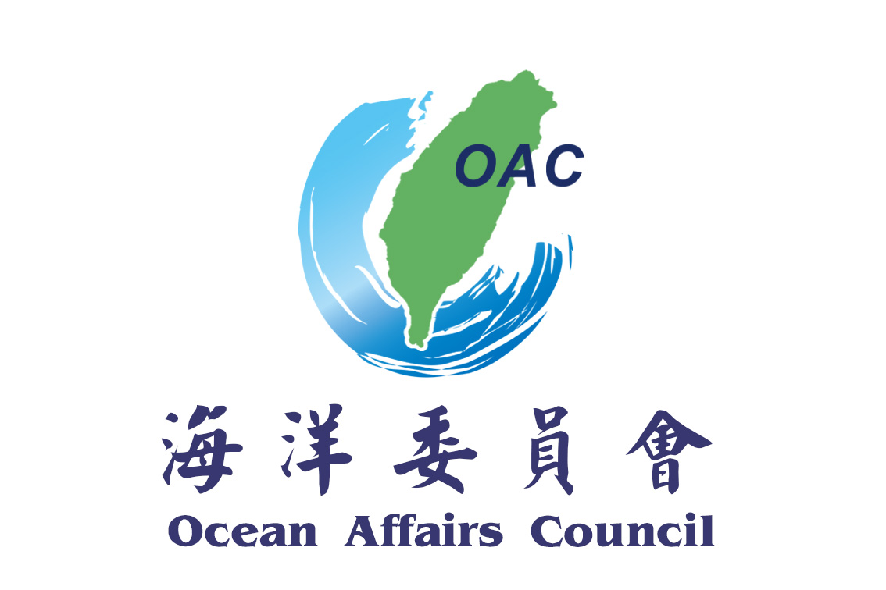
海洋委員會新聞稿
發稿單位及聯絡人：國際發展處紀視察
(07-3381810#261323)
發稿日期: 109年2月11日

歐洲經貿辦事處拜會海洋委員會 就海洋事務進行對話

歐洲經貿辦事處雍青龍副處長今（11）日拜會海洋委員會，雙方就歐盟關切之打擊IUU漁業執法面向、海洋教育活動、離岸風電與海洋保育、黑潮發電等科研技術議題，廣泛進行交流討論。
蔡清標政務副主任委員表示，海洋委員會成立後積極推動我國海洋政策及相關涉海業務，並於去年11月通過「海洋基本法」。近年來，本會海巡署就打擊IUU漁業之執行面提供諸多具體協助，例如海上登檢及港口檢查等事項。期待未來進一步就海事安全、海洋產業、海洋保育、海洋教育等各面向與歐盟進行全方位的合作交流，並推展臺歐盟海洋事務對話機制，深化與歐盟夥伴關係，為海洋永續發展共盡心力。
雍青龍副處長表示，目前臺歐盟在海洋事務的推動上，主要以臺歐盟打擊IUU漁業工作方面為基礎，非常樂見未來持續互訪，討論推動相關具體合作項目。
蔡清標政務副主任委員另表示，本會與歐洲在臺商務協會將於4月25日在高雄旗津海岸合辦淨灘活動，以及本會預定在6月上旬舉辦國家海洋日系列活動，誠摯邀請歐洲經貿辦事處及社會大眾屆時共襄盛舉。

(摘譯)

Deputy Director THOMAS JÜRGENSEN of EETO meets Deputy Minister Tsai of OAC to promote cooperation and exchanges of marine issues
The Deputy Director of European Economic and Trade Office (EETO), Thomas JÜRGENSEN, met Deputy Minister Tsai, Ching-Piao of the Ocean Affairs Council (OAC) on February 11 to exchange opinions about law enforcement to eliminate IUU fishing, marine environmental education and marine scientific research.
Deputy Minister Tsai, Ching-Piao said that OAC established the “Ocean Basic Act” in November 2019, which serves as the highest guiding principle for the ocean policy. In recent years, Coast Guard Administration of OAC has provided specific assistance in combating IUU fishing, such as fishing vessels boarding & inspection and port enter & exit checks. OAC looks forward to extensive cooperation and exchanges with the European Union on maritime safety, marine industry, marine conservation, marine education to deepen the Taiwan-EU partnership in the future and working together for ocean sustainable development.
The Deputy Director of EETO Thomas JÜRGENSEN said that the promotion of Taiwan-EU ocean affairs now is mainly based on the efforts to combat IUU fishing. It is very welcome to continue to visit each other and discuss specific cooperation projects.
Deputy Minister Tsai, Ching-Piao also said that OAC and European Chamber of Commerce Taiwan (ECCT) in Taiwan organized a clean-up beach event on the Qijin Coast in Kaohsiung on April 25th, and OAC is planning a series of National Ocean Day activities in early June. OAC sincerely invite EETO and the public to participate in the events.

